**Logging**

Logging is the process of recording run-time actions as they happen in real-time.

Helps us to understand the failures and performance bottlenecks of the application.

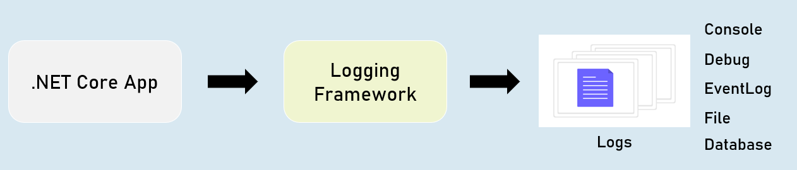

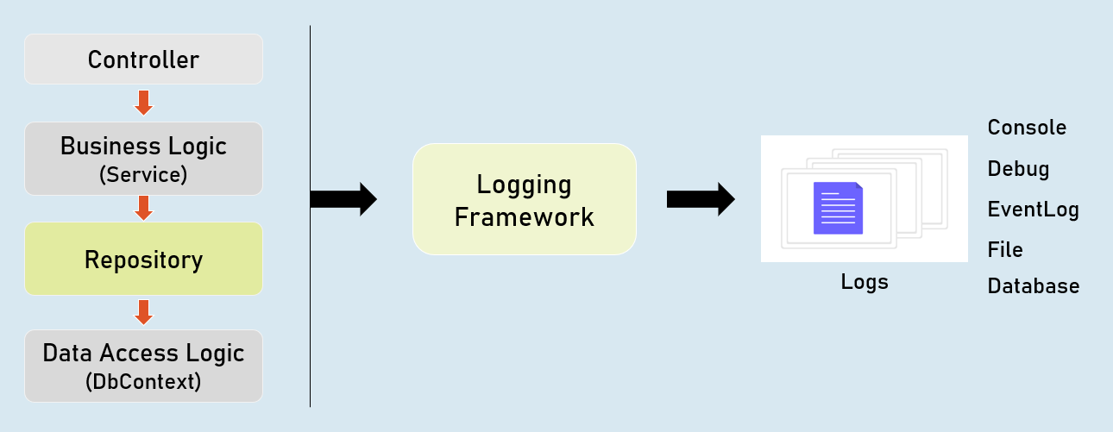

**ILogger**

**Debug**

ILogger.LogDebug("log_message");

Logs that provide details & values of variables for debugging purpose.

**Information**

ILogger.LogInformation("log_message");

Logs that track the general flow of the application execution.

**Warning**

ILogger.LogWarning("log_message");

Logs that highlight an abnormal or unexpected event.

**Error**

ILogger.LogError("log_message");

Logs to indicate that flow of execution is stopped due to a failure.

**Critical**

ILogger.LogCritical("log_message");

Logs to indicate an unrecoverable application crash.

**Logging Configuration**

**appsettings.json**

{

"Logging": {

"LogLevel": {

"Default": "Debug | Information | Warning | Error| Critical"

"Microsoft.AspNetCore": "Debug | Information | Warning | Error | Critical"

}

}

}

**Controller and other classes**

using Microsoft.AspNetCore.Mvc;

using Microsoft.Extensions.Logging;

public class ControllerName : Controller

{

private readonly ILogger<ClassName> _logger;

public ControllerName(ILogger<ClassName> logger)

{

_logger = logger;

}

}

**Logging Providers**

Logging provider specifies where to store / display logs.

The built-in logging providers in asp.net core doesn't support file / database logging providers.

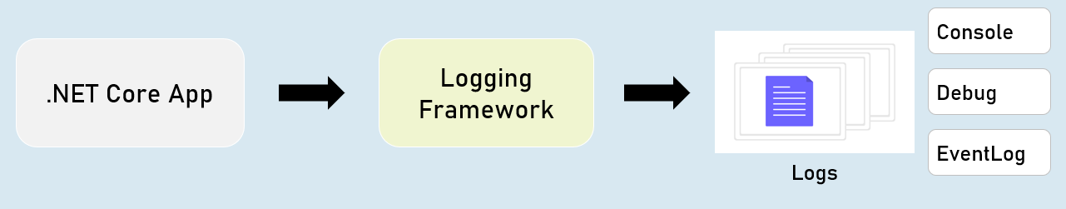

in **Program.cs:**

builder.Host.ConfigureLogging(logging =>

{

logging.ClearProviders();

logging.AddConsole();

logging.AddDebug();

logging.AddEventLog();

});

**HTTP Logging**

Logs details all HTTP requests and responses.

You need to set a value of "HttpLoggingFields" enum to set specify desired details.

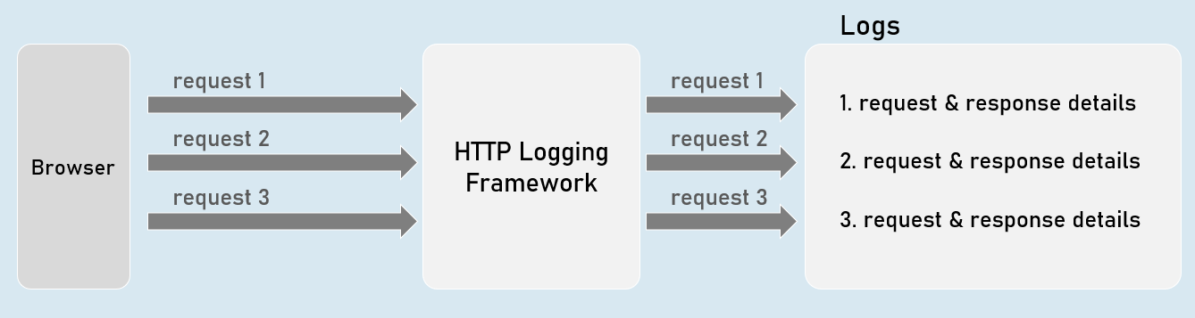

**HTTP Logging Options**

**"HttpLoggingFields" enum:**

**RequestMethod**

Method of request. Eg: GET

**RequestPath**

Path of request. Eg: /home/index

**RequestProtocol**

Protocol of request. Eg: HTTP/1.1

**RequestScheme**

Protocol Scheme of request. Eg: http

**RequestQuery**

Query string Scheme of request. Eg: ?id=1

**RequestHeaders**

Headers of request. Eg: Connection: keep-alive

**RequestPropertiesAndHeaders**

Includes all of above (default)

**RequestBody**

Entire request body. [has performance drawbacks; not recommended]

**Request**

Includes all of above

**"HttpLoggingFields" enum**

**ResponseStatusCode**

Status code of response. Eg: 200

**ResponseHeaders**

Headers of response. Eg: Content-Length: 20

**ResponsePropertiesAndHeaders**

Includes all of above (default)

**ResponseBody**

Entire response body. [has performance drawbacks; not recommended]

**Response**

Includes all of above

**All**

Includes all from request and response

**HTTP Logging Options**

Program.cs:

builder.Serices.AddHttpLogging(options =>

{

options.LoggingFields = Microsoft.AspNetCore.HttpLogging.HttpLoggingFields.YourOption;

});

**Serilog**

Serilog is a structured logging library for Asp.Net Core.

Supports variety of logging destinations, referred as "Sinks" - starts with Console, Azure, DataDog, ElasticSearch, Amazon CloudWatch, Email and Seq.

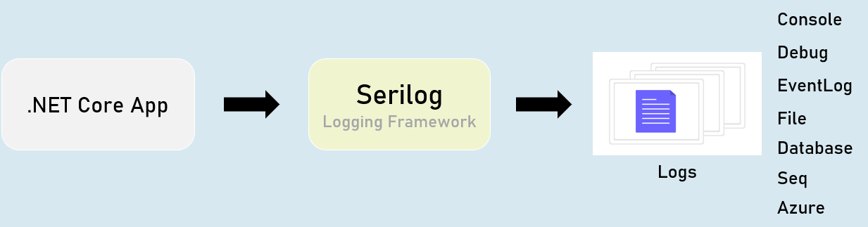

**Serilog - Configuration**

**appsettings.json**

{

"Serilog": {

"Using": [

"Serilog.Sinks.YourSinkHere"

],

"MinimumLevel": "Debug | Information | Warning | Error | Critical",

"WriteTo": [

{

"Name": "YourSinkHere",

"Args": "YourArguments"

}

]

}

}

**Serilog - Options**

**Program.cs:**

builder.Host.UseSerilog(HostBuilderContext context,

IServiceProvider services, LoggerConfiguration configuration) =>

{

configuration

.ReadFrom.Configuration(context.Configuration) //read configuration settings from built-in IConfiguration

.ReadFrom.Services(services); //read services from built-in IServiceProvider

});

**Serilog - File Sink**

**The "Serilog.Sinks.File" logs into a specified file.**

You can configure the filename, rolling interval, file size limit etc., using configuration settings.

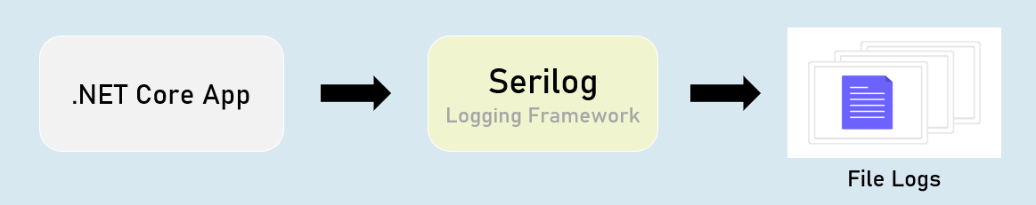

**Serilog - "File Sink" Configuration**

**appsettings.json**

{

"Serilog": {

"Using": [ "Serilog.Sinks.File" ],

"MinimumLevel": "Debug | Information | Warning | Error | Critical",

"WriteTo": [

{

"Name": "File",

"Args": [

"path": "folder/filename.ext",

"rollingInterval": "Minute | Hour | Day | Month | Year | Infinite",

]

}

]

}

}

**Serilog - Database Sink**

The "Serilog.Sinks.MSSqlServer" logs into a specified SQL Server database.

You can configure the connection string using configuration settings.

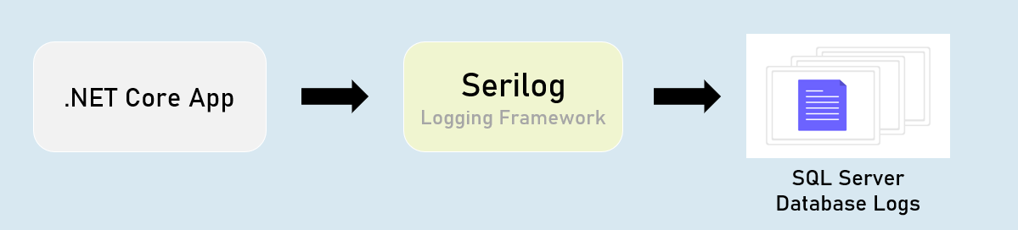

**Serilog - 'MSSqlServer' Sink Configuration**

**appsettings.json**

{

"Serilog": {

"Using": [ "Serilog.Sinks.MSSqlServer" ],

"MinimumLevel": "Debug | Information | Warning | Error | Critical",

"WriteTo": [

{

"Name": "MSSqlServer",

"Args": [

"connectionString": "your_connection_string_here",

"tableName": "table_name",

]

}

]

}

}

**Serilog - Seq Sink**

The "Serilog.Sinks.Seq" is a real-time search and analysis server for structured application log data.

Seq server can run on Windows, Linux or Docker.

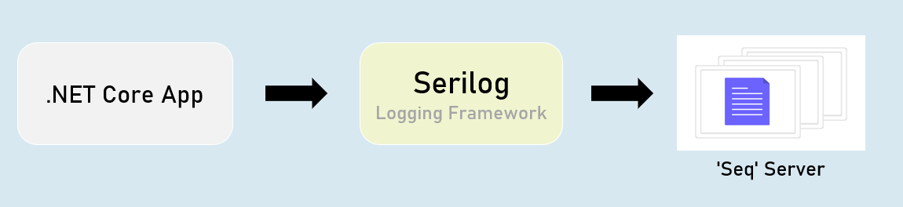

**Serilog - 'Seq' Sink - Configuration**

**appsettings.json**

{

"Serilog": {

"Using": [ "Serilog.Sinks.Seq" ],

"MinimumLevel": "Debug | Information | Warning | Error | Critical",

"WriteTo": [

{

"Name": "Seq",

"Args": [

"serverUrl": "http://localhost:5341"

]

}

]

}

}

**Serilog - RequestId**

"RequestId" is the unique number (guid) of each individual requests, used to identify to which request the log belongs to.

RequestId is "TraceIdentifier" internally, that is generated by Asp.Net Core.

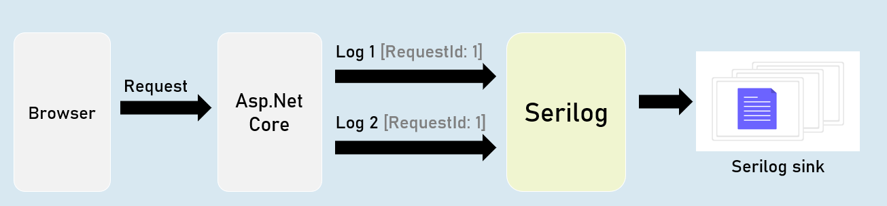

**Serilog - Enrichers**

Enrichers are additional details that are added to LogContext; so they're stored in logs.

Eg: MachineName[or]Custom Properties.

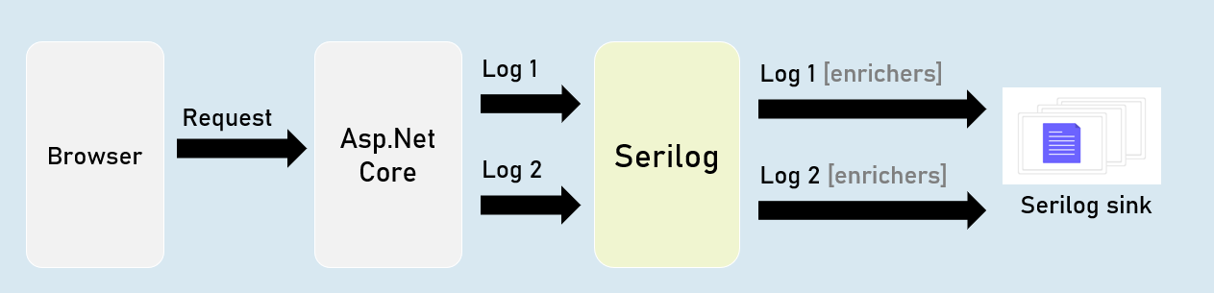

**Serilog - IDiagnosticContext**

Diagnostic context allows you to add additional enrichment properties to the context; and all those properties are logged at once in the final "log completion event" of the request.

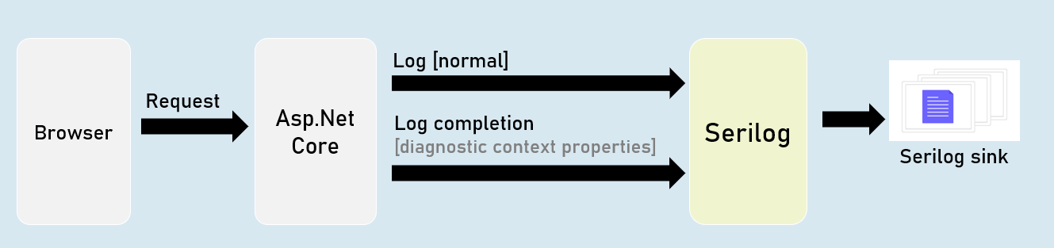

**Serilog Timings**

"SerilogTimings" package records timing of a piece of your soure code, indicating how much time taken for executing it.

